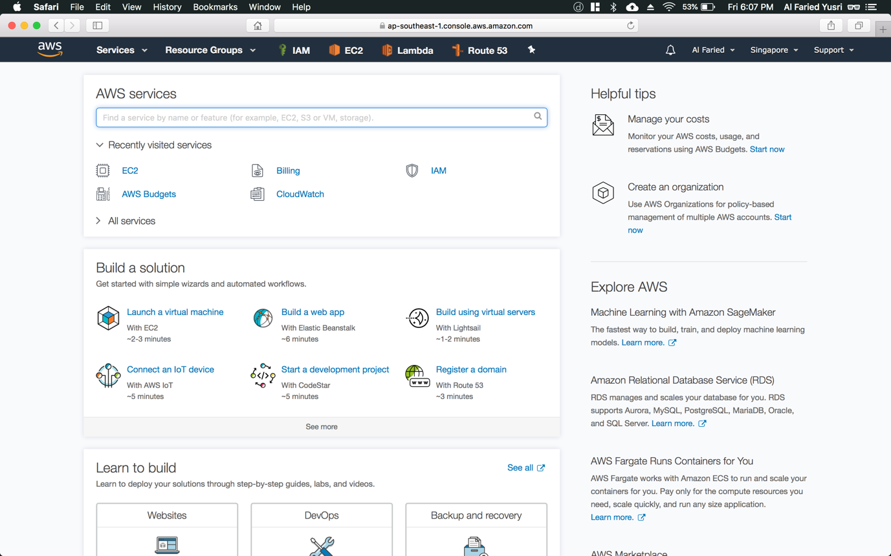

Step 1: Navigate to your name on the top right hand (refer to Figure 1.1) corner and click on the drop-down list

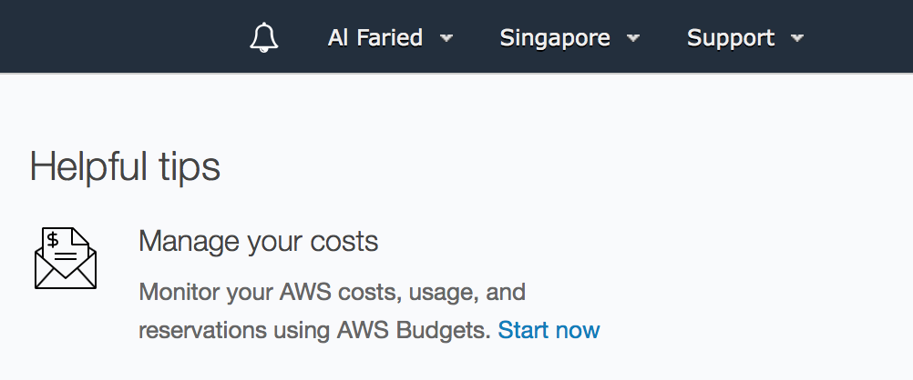

Figure 1.1

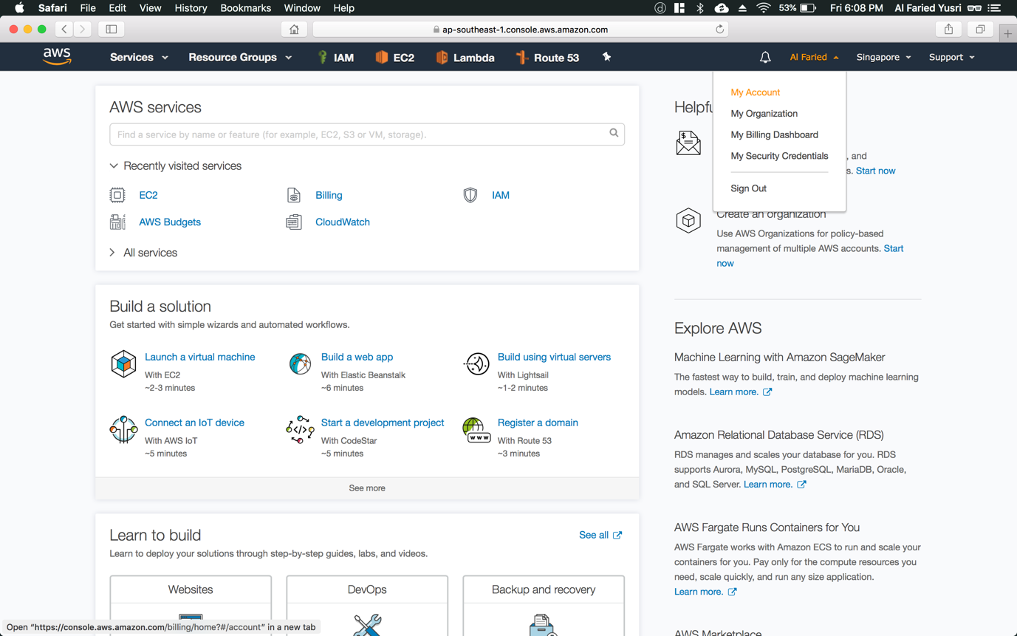

Step 2: Click on the “My Account” option

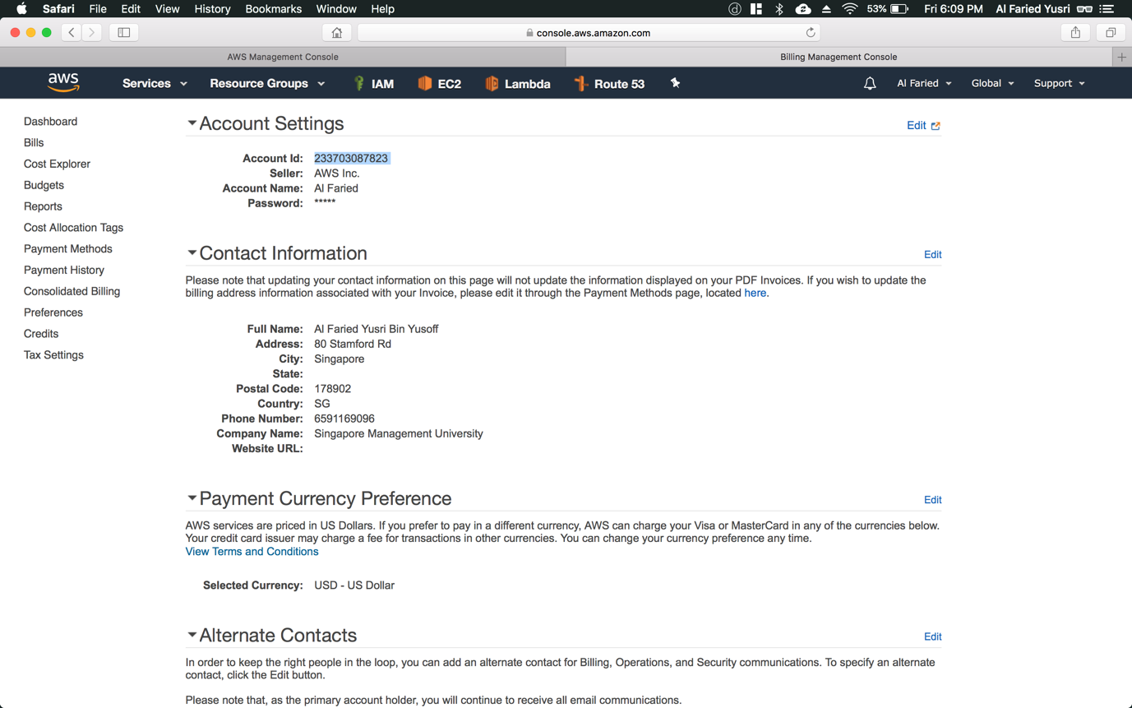

Step 3: Copy the value “Account Id” (refer to Figure 1.2) and paste it in textbox below (or in our CLE application – IT Ops Labs portion)

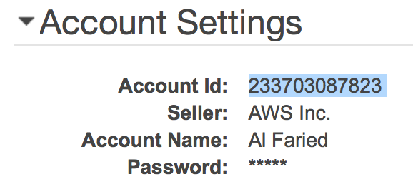

Figure 1.2